Topic 3: Real Estate

Chapter 6: Real Estate Investment Trusts

- Explain the advantages and disadvantages of real estate investment trusts (REITs).

- Avoids DOUBLE TAXATION of taxes at both the corporate and individual levels.
- Shares of the REIT can be freely traded on the exchange.
- REITS facilitate asset allocation which comes at two levels.
  - REITS as a part of a Strategic Asset Allocation (SAA) to real estate as an asset class.
  - Investors can use Tactical Asset Allocation (TAA) by tilting their real property exposure to certain parts of the real estate market.
- They offer professional asset management by the executives.
- REITS provide a consistent dividend – healthcare, Industrial and Residential all had dividend yields over 7% as of May 2009.
- Last REITS are overseen by an independent board of directors.

Disadvantages: www.reits.com

- On the exchange prices pick up some of the systematic risk associated with the broader stock market. This reduces their diversification benefits. Therefore, REITS are less of a pure play in real estate.
- Dividend distributions are taxed at ordinary income rates. Simply, REITs are less tax efficient for high tax bracket investors.

- Differentiate the types of REITs as they pertain to investment philosophy, structure, and the markets in which the invest

- Equity REIT
- Uses pooled capital from investors to purchase property directly.
- The REIT is the equity owner of the properties underlying the REIT
- An equity REIT will also manage, renovate, and develop real estate
- Produces revenue for its investors from the rental and lease payments it receives as the landlord of the properties it owns
- Rental and lease receipts tend to increase along with inflation making REITs a potential hedge against inflation

- Mortgage REIT
- They are lenders to owners, developers, and purchases of real estate.
- Pure mortgage REITs, however, do not own any real estate property directly. They generate returns for their shareholder from the interest earned on the financing they provide.
- Derives its value from financing the purchase or real estate properties.

- Hybrid REITs
- Invest in both the equity and the debt of the real estate properties.
- Can do an unlimited combination or real estate investing and mortgage financing

REIT Structures
- Single Property REIT
 Note: “Rockefeller”
- Accumulates capital to purchase a single large property.
- Rockefeller Center in New York City is a very large collection of office buildings, shopping promenades, and dining establishments grouped together in the center of Manhattan.

- Finite Life REIT

- Establishes a termination date by which the REIT will sell its underlying properties and wind up its affairs.
- The typical term is 8 to 15 years.

- Dedicated REIT
 Note: “Old Orchard”

- is typically established to invest in one type of property only (retail strip malls)
- a single development (like a LaSalle Partners developed set of office buildings)
- a geographic region

- Umbrella Partnership

- Created to avoid taxable income on the transfer of appreciated property
- Like a Holding Company. Holds ALL properties.
- You contribute property in exchange for limited partnership units and a ‘put’ option
- Driven by Tax Consequences
- Put can be converted to REIT shares or cash which is avoided b/c of taxes
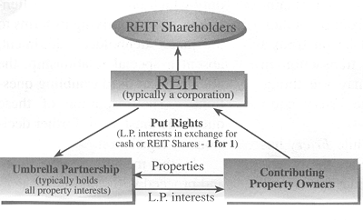

- DOWN REIT

- Created for additional structuring flexibility
- Down REIT is a joint venture between the REIT and the property owner
- Holds Specific properties

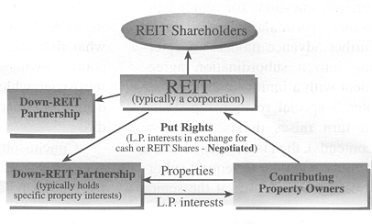

- Discuss the rules that REITS must obey to obtain tax-advantage status

- It must be organized as a corporation or trust.
- It must be managed by one or more trustees or directors.
- Its shares must be transferrable, usually accomplished by listing the REIT shares publicly on an exchange.
- It cannot be a financial institution or an insurance company.
- It must be owned by 100 or more persons.
- No more than 50% of the REITS shares can be owned by five or more persons.

- Discuss the Economic Benefits of REITs compared to other assets

  - Sharpe is higher for REITs than for large cap or small cap stocks, and high yield bonds.
  - REIT returns are higher vs large-cap (200 bps) or small cap stocks (160 bps).
  - The correlation between REITs and Treasury bonds is negative.
  - REITs have the highest correlation with High Yield bonds.
  - Most REITs would be classified as small/mid cap. More correlated to Russell 2000
  - Often thought of as a hedge to inflation.
- Because rental/lease payments are typically adjusted upward during times of inflation.
- REIT values tend to increase during periods of inflation as investors shift their portfolios away from financial assets to real assets.
- However, there is a negative relationship between REIT dividend yields and inflation.

Chapter 7: NCREIF Property Index



National Council of Real Estate Investment Fiduciaries
- Classify and describe the types of properties underlying the NPI (NCREIF Property Index)

- office (36.6% of the index),
- apartment (24.1% of the index),
- retail (22.1% of the index),
- industrial (15.3% of the index),
- hotel (2.0% of the index).

 OAR: Offices, Apartments, Retail = 80% of the index.

- Describe the two methods used to appraise properties and critique appraisal-based indices

- Comparable Sales method
- Discounted cash flow method (DCF)

Criticisms
- NPI index tends to exhibit lower volatility than is believed
- Appraisal values tend to lag the true real estate market values
- May suffer from infrequent transactions
- Overstates the diversification benefits of real estate
- Unleveraged NPI misstates the true performance of the index

- Explain the three practical effects arising from the smoothing process, including the effects of adding leverage to the NPI, and the methods used to unsmooth the NPI

- Lagging of Returns
- Lower volatility
- Decreased correlations (with stocks and bonds)

Effects of adding leverage to the NPI:
- Another issue with the NPI is that it is an unleveraged index. Basically, just says it makes returns more volatile.

Methods used to UNsmooth the NPI

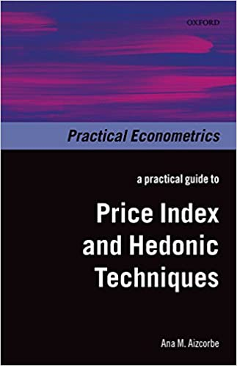 Note: “Hedonic”

  - Hedonic price index (compares a lot of heterogeneous things)
  - Using properties that have recently been sold
  - Appraisal and lagging process
  - Unsmooth econometrically to remove the embedded lag on the time series

Chapter 8: Real Estate as an Investment

- Explain the five goals for adding real estate to an investment portfolio

1. To achieve absolute returns above the risk-free rate
2. To provide a hedge against inflation
3. A portfolio diversification tool
4. To constitute an investment portfolio that resembles the global investment opportunity set
5. To deliver strong cash flows to the portfolio through lease and rental payments

Direct Investment in Real Estate will shift the efficient curve up and to the left.

- Compare historical risk, return and risk-adjusted real estate returns to other asset classes and draw relevant conclusions

- Real estate has Negative skew and Leptokurtosis over the last 20 years.
- Serious EVENT risk. 2008 was brutal.
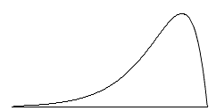

- Describe the diversification benefits of real estate in terms of its correlation coefficients with other asset classes, as a hedge against inflation, and its capacity to expand the efficient frontier when combined to a portfolio of stocks and bonds

Correlation
- REITs have the highest correlation with High Yield bonds.
  - Most REITs would be classified as small to mid cap rather than large cap. So, more correlated to Russell 2000.
Hedge to Inflation
- Because rental/lease payments are typically adjusted upward during times of inflation.
- REIT values tend to increase during periods of inflation as investors shift their portfolios away from financial assets to real assets.
- REIT dividend yields not good because dividends often lag increases in lease rates and lease rates reaction to inflation.
Capacity to Expand the Efficient Frontier

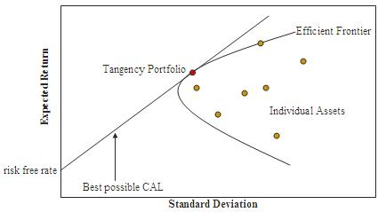

Chapter 9: Core, Value Added, and Opportunistic Real Estate

1. Compare and contrast the 3 National Council of Real Estate Investment
Fiduciaries (NCREIF) real estate styles and discusses the eight attributes that help to distinguish the type of property.

Style boxes are essentially locators. Style investing is all about the space in which the investment manager operates. Styles identify where and how an investment manager invests.

- Core
- Most liquid. Office, retail, apartment, and industrial real estate.
- Least leveraged
- Most recognizable
- Majority of their returns come from cash flows

- Value Added

- Off the beaten path. Hotels, resorts, assisted care, low income house, malls, hospitals
- Produce less income and more property appreciation
- Value-added investments are typically non-core assets with a large portion of returns realized through price appreciation with moderate volatility.

- Opportunistic
- Majority of the return comes from value appreciation over a 3-5 year period
- More like ‘traders’ who manage these things
- Way for intuitional investor to get out of the country
- Often accessed through real estate opportunity funds, sometimes called PEREs
- PSERS sets the hurdle rate at 13%
- DATA is limited because usually takes places place through private limited partnerships
- More of a European thing

- Property type
- Life Cycle
- Occupancy
- Rollover concentration
- Near-term rollover
- Leverage
- Market recognition
- Investment structure/control

http://www.reit.com/
NAREIT Index. National Association of Real Estate Investment Trusts
- REITS are marked-to-market daily and returns are calculated using transactions, they reflect actual market values of the underlying properties and the leverage.
- The index will be far more volatile than the indices of the NCREIF

2. Assess the returns and risks associated with real estate style boxes from an absolute and a relative return investor perspective.

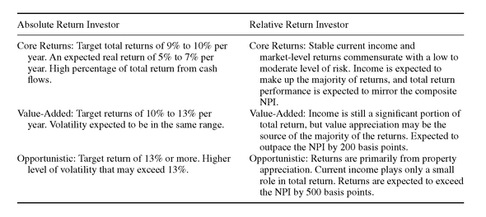

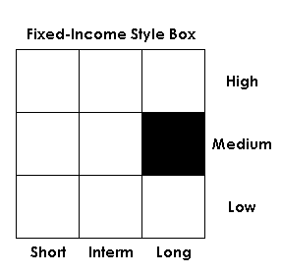 Style Box
- Core expected to mirror the NPI in returns
- Value Added: outpace the NPI by 200 basis points
- Opportunistic: outpace the NPI by 500 basis points

3. Describe the cross-section distribution of NPI component property returns.

Histogram used to observe the pattern of real estate returns over time.
- NCREIF Property Index (NPI) is calculated quarterly 1/4 with carried appraisal intervals
- In 2007, the median return (50th percentile) on a cross-sectional distribution of NPI sector returns was 15.85%.
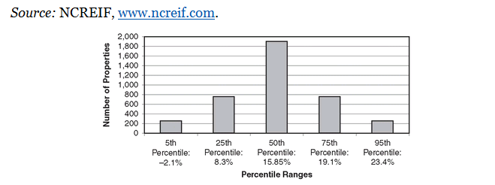

4. Discuss the characteristics of Private Equity Real Estate. (PERE)

- Leverage is typically used at a very high level. Capital structure is generally very complex.
- Valuations can be very difficult
- PERE investments are not exclusive to opportunistic properties.
- Private equity real estate is a professionally managed fund that invests in real estate.
- Unlike REITs, private equity real estate investing requires a substantial amount of capital and may only be available to high-net-worth or accredited investors.
- This type of investment is often riskier and costlier than other forms of real estate investment fund but returns of 8% to 10% are not uncommon.

